Chapter 1
INTRODUCTION
  - INTRODUCTION
A collar belt for livestock integrated with live tracking is a smart farming solution designed to help farmers manage and protect their animals more effectively. The collar is worn around the animal’s neck and uses tracking technology to show the real-time location of livestock. This system helps farmers keep watch over animals even when they are grazing in large or remote areas. It reduces the need for constant physical supervision and saves time and effort. Live tracking also helps in preventing loss, improving animal safety, and supporting better decision-making.

  - Brief history of Collar belt of livestock

The use of collar belts for livestock began with simple leather collars used for identification and bells to locate animals. Over time, collars evolved to include tags, GPS tracking, and sensors, helping farmers monitor location, health, and behavior using modern technology.

  - Collar belt for Livestock
The livestock collar belt with live tracking helps farmers manage animals efficiently. Using geo fencing, it prevents animals from wandering and reduces thief loss. It supports reduction of man labour by remote monitoring, improves herd health, tracks grazing patter, and enables continuous behavior monitoring for better farm decisions.

Chapter 2
Problem Statement
2.1 Description
Livestock Tracking and Management: IoT devices such as GPS trackers are used to monitor the location and movement of livestock. This helps farmers prevent theft, track grazing patterns, and manage herd health

2.2 Challenge Statement
Farmers face challenges in continuously monitoring livestock location, health, and movement over large grazing areas. The lack of real-time tracking leads to theft risks, inefficient grazing management, and delayed detection of health issues.

Chapter 3
3.1 Design Thinking Process

  - Empathize: Interviews with 30+ students, 7 faculty, and 3 administrators revealed delays, failed scans, and mismatches.
  - Define: Key needs identified: faster scanning, offline capability, reliable syncing, real‑time visibility.
  - Ideate: Generated 10+ ideas. Final solution selected: biometric + IoT device with dashboard.
  - Prototype: A hardware prototype with fingerprint sensor, microcontroller, and IoT connectivity was developed.
  - Test: Testing reduced queue time from 10 minutes to ~1 minute with 100% accuracy during trials
3.2 Methodology
(Working procedure Flow chart with description)
3.3 Prototype Description
Collar belts for livestock management and tracking address the critical problem of inefficient monitoring in modern agriculture. Farmers struggle with labor-intensive practices, theft risks, and limited visibility into animal health and movement. Smart collar belts equipped with IoT sensors, GPS, and predictive analytics provide real-time data on location, activity, and vital signs. This technology enhances productivity, reduces losses, and supports sustainable farming by enabling data-driven decisions. In today’s market society, where food security, supply chain transparency, and resource optimization are industry priorities, livestock tracking solutions meet urgent needs for efficiency, accountability, and scalability in agriculture and allied industries.

3.3.1 Materials Used ( With specific images, descriptions and specifications)
- Arduino Uno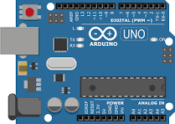Arduino Uno is a popular microcontroller board used for electronics and IoT projects. It is easy to program, low cost, and supports sensors, GPS, and communication modules, making it ideal for student projects and smart farming applications.
- GPS NEO 6M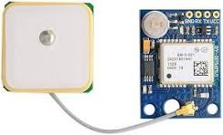GPS NEO-6M is a compact satellite positioning module used to find accurate location coordinates. It supports real-time tracking, works well with Arduino, and is commonly used in navigation, vehicle tracking, and livestock monitoring projects.

3.3.2 System Diagram (Circuit connection diagram/Software architecture/product architecture with description)

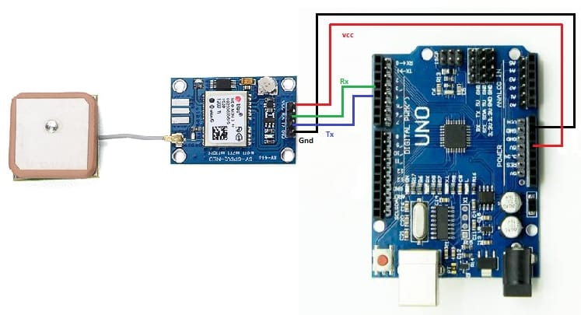

Arduino Uno connects to the GPS NEO-6M using serial communication. The GPS TX pin connects to Arduino RX, GPS RX to Arduino TX, VCC to 5V (or 3.3V as required), and GND to GND for power and data transfer.

Chapter 4
Implementation
( Insert codes used in this project)
#include <TinyGPS++.h>
#include <TinyGPSPlus.h>
#include <SoftwareSerial.h>

TinyGPSPlus gps;
SoftwareSerial GPS(3, 4);

void setup()
{
Serial.begin(9600);

GPS.begin(9600);

Serial.println("Program started");
}

void loop()
{
if (GPS.available() > 0)
{
gps.encode(GPS.read());

if (gps.location.isUpdated())
{
Serial.print("Latitude = ");
Serial.print(gps.location.lat(), 6);
Serial.print(" Longitude = ");
Serial.print(gps.location.lng(), 6);
}
}
}

Chapter 5
Results and Analysis
User Testing & Feedback
TEST - A farmer manages a large grazing area with many livestock, making it difficult to monitor each animal manually. By using IoT-based GPS trackers, the farmer can view real-time location and movement of livestock. This system helps prevent theft by sending alerts when animals move outside safe zones. It also tracks grazing patterns, allowing better land use. Activity data supports early detection of health issues, helping the farmer maintain overall herd health efficiently and reduce daily monitoring effort.

Chapter 6
Conclusion & Future Work
IoT-based livestock tracking improves farm efficiency by ensuring animal safety, reducing theft, and supporting better grazing and health management. This technology helps farmers make informed decisions while saving time, effort, and resources in daily livestock care.

Future Work:-
Solar panel battery pack
Wireless and more smooth precise trackers
Health tracker

